**Exercise 1: Control Structures**

-- Scenario 1: Apply 1% discount to loan interest rates for customers above 60 years old

BEGIN

    FOR cust_rec IN (SELECT CustomerID, Age FROM Customers) LOOP

        IF cust_rec.Age > 60 THEN

            UPDATE Loans

            SET InterestRate = InterestRate - 1

            WHERE CustomerID = cust_rec.CustomerID;

        END IF;

    END LOOP;

    COMMIT;

END;

/

-- Scenario 2: Set IsVIP flag to TRUE for customers with balance over $10,000

BEGIN

    FOR cust_rec IN (SELECT CustomerID, Balance FROM Customers) LOOP

        IF cust_rec.Balance > 10000 THEN

            UPDATE Customers

            SET IsVIP = 'TRUE'

            WHERE CustomerID = cust_rec.CustomerID;

        END IF;

    END LOOP;

    COMMIT;

END;

/

-- Scenario 3: Send reminders for loans due within the next 30 days

BEGIN

    FOR loan_rec IN (

        SELECT CustomerID, DueDate FROM Loans

        WHERE DueDate BETWEEN SYSDATE AND SYSDATE + 30

    ) LOOP

        DBMS_OUTPUT.PUT_LINE('Reminder: Loan due for Customer ID ' || loan_rec.CustomerID || ' on ' || TO_CHAR(loan_rec.DueDate, 'DD-MON-YYYY'));

    END LOOP;

END;

/

**OUTPUT**



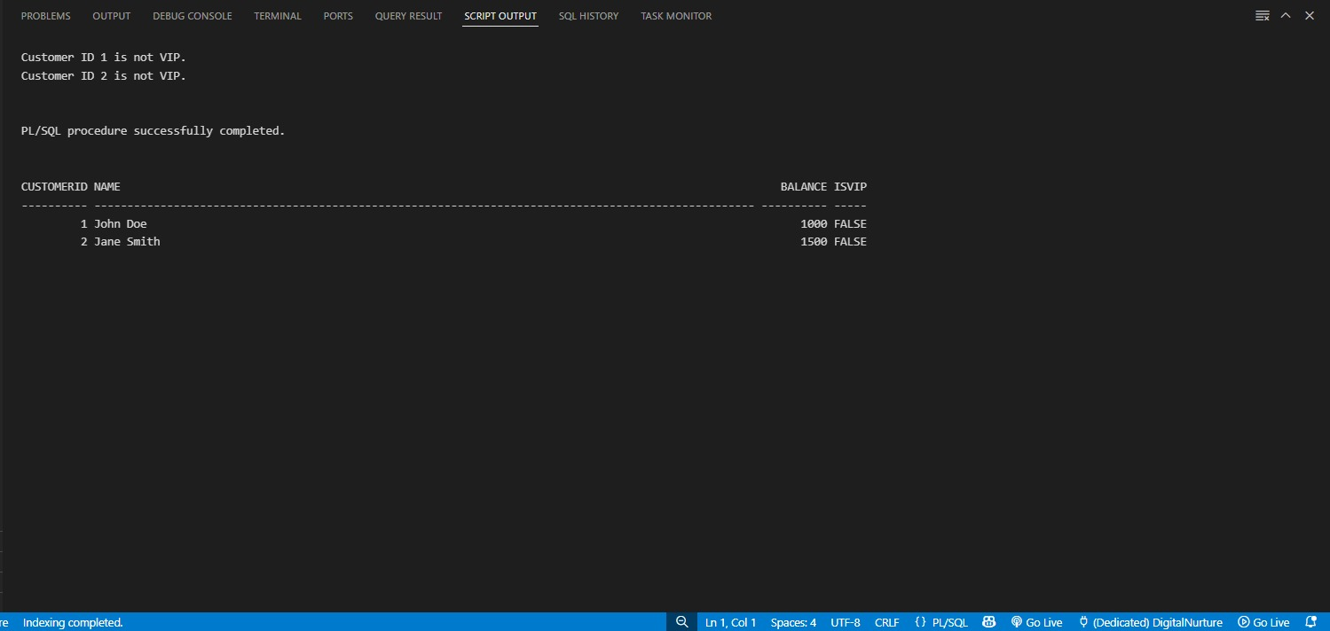

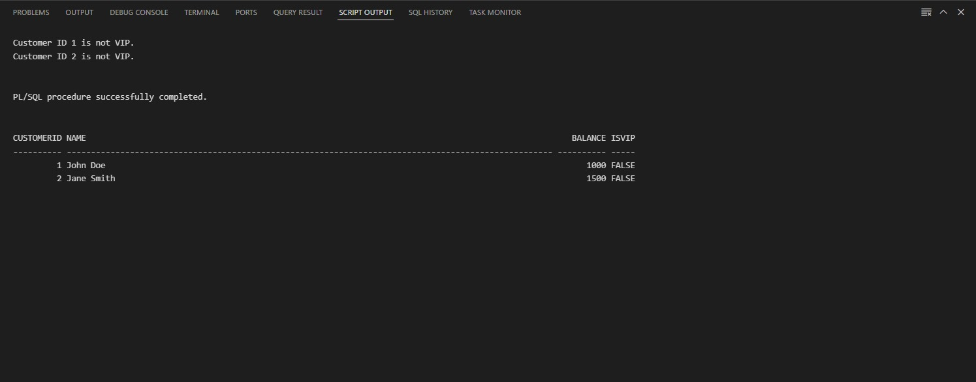

**Exercise 3: Stored Procedures**

-- Scenario 1: ProcessMonthlyInterest stored procedure

CREATE OR REPLACE PROCEDURE ProcessMonthlyInterest IS

BEGIN

    FOR acc_rec IN (SELECT AccountID, Balance FROM Accounts WHERE AccountType = 'Savings') LOOP

        UPDATE Accounts

        SET Balance = Balance + (Balance * 0.01)

        WHERE AccountID = acc_rec.AccountID;

    END LOOP;

    COMMIT;

END;

/

-- Scenario 2: UpdateEmployeeBonus stored procedure

CREATE OR REPLACE PROCEDURE UpdateEmployeeBonus(

    dept_id IN NUMBER,

    bonus_percent IN NUMBER

) IS

BEGIN

    UPDATE Employees

    SET Salary = Salary + (Salary * bonus_percent / 100)

    WHERE DepartmentID = dept_id;

    COMMIT;

END;

/

-- Scenario 3: TransferFunds stored procedure

CREATE OR REPLACE PROCEDURE TransferFunds(

    from_account_id IN NUMBER,

    to_account_id IN NUMBER,

    amount IN NUMBER

) IS

    from_balance NUMBER;

BEGIN

    SELECT Balance INTO from_balance FROM Accounts WHERE AccountID = from_account_id FOR UPDATE;

    IF from_balance >= amount THEN

        UPDATE Accounts

        SET Balance = Balance - amount

        WHERE AccountID = from_account_id;

        UPDATE Accounts

        SET Balance = Balance + amount

        WHERE AccountID = to_account_id;

        COMMIT;

    ELSE

        RAISE_APPLICATION_ERROR(-20001, 'Insufficient balance in source account.');

    END IF;

END;

/

**OUTPUT**

